A Special Message For Anyone Who Has Panic Attacks

Proof
"Proof At Last That Panic Attacks And Anxiety Can Be Eliminated For Good"
Regardless Of What You Have Been Led To Believe Acute Anxiety And Panic Attacks Can Be Cured In Easy To Follow Steps Without Any Medication Using A Revolutionary New Technique
Renowned Anxiety Expert Joe Barry Has Taught Thousands Of People To Be Panic Free. -Here Is How...

From Joe Barry
October 17, 2005
Dear Friend
Have you experienced the terrifying sensations of a panic attack? Do you suffer from anxiety or its associated symptoms. If so, you are not alone. More and more people right across the world, are reporting to suffer from anxiety and panic attacks. This is a very unfortunate but totally unnecessary experience.
Are any of these symptoms familiar to you during an anxiety episode?
- Dizzy spells leading to panic
- Tightness in throat and chest- shortness of breath
- Racing heart with tingle sensations
- Obsessive worries and unwanted thoughts
- Overwhelming fear that something awful is about to occur
These and other similar uncomfortable sensations are all too common but the truth is you do not have to ever suffer from another panic attack or anxiety attack again -I'll explain why.
Most of the people I deal with have been struggling with anxiety disorders for many years and have usually exhausted themselves looking for a solution in every book, course, or treatment program out there. By the time they get to me, they have little faith in ever getting rid of their condition. This does not have to be the case with you.
Soon I'll Be Showing You The Most Powerful Technique For Eliminating Anxiety And Panic Attacks

The technique I teach has been developed by me, a former sufferer of all too frequent panic attacks. I developed a completely natural approach to eliminating 100% of anxiety and panic attacks within minutes. This may seem very hard to believe for someone who may have had this condition for some time but believe me the new information is now available to be free from anxiety. I will reveal the whole technique to you.
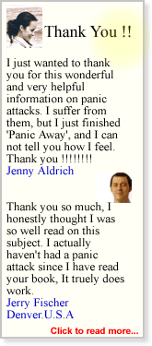
You will be amazed at how such a simple technique known as the One Move™ technique could be so powerful in restoring you back to your former care free self. I am not talking about just eliminating panic attacks but also getting your general anxiety level right back down to zero without the use of any medication or relaxation techniques.
Your anxiety will vanish
Your Confidence Will Soar
and the results last a lifetime
Best of all...
- It does not rely on old techniques such as 'deep breathing' or 'positive affirmations'.
- It takes seconds to implement wherever you are, at home, at work or out socializing with friends.
- You will no longer have to spend anymore money on expensive doctor or therapist visits.
- You will not be asked to follow a complicated 30 step program that will bring only minor improvements.
- After reading this information you will be able to immediately have confidence to tackle any of the big stresses you may have been putting off e.g. driving, air travel, interviews etc.
Getting You Back To Your Former Self Is What Is Important ...That's Our Goal Together
You let me put the technique to work for you and with pure joy you will see calm being restored to your life. I developed and refined this technique over the past 10 years and chances are you will not have come across anything like it before.
If you will let me I will tell you something extremely important about anxiety and panic attacks. This is crucial if you are to seriously begin on the road to full recovery
OK, here goes..
This Is The Key To Being Panic Attack Free...
You Must Learn To Break The Fear Of Having Another Panic Attack Or You Will Never Experience Complete Freedom From Anxiety

-The anticipation of a panic attack starts the cycle of anxiety in motion.
-The foundation of a future panic attack is laid hours before you actually experience one.
-The slightest trigger will then launch the full blown panic attack into motion.
-Panic arrives in wave like formations washing over your mind/body.
This Is Where Your Problem Lies
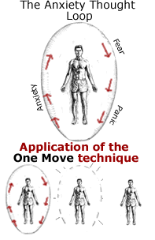
There is one key factor that makes the difference between those who fully eliminate panic attacks from their lives and those who do not. The key ingredient is not medication, lifestyle changes, or relaxation exercises. It is when the individual no longer fears the thought of having a panic attack. This may seem like a simplified and obvious observation but give it careful consideration. The one thing that has you searching for a solution to anxiety and panic attacks this very moment is the fear of having another one.
The first time a person experiences a panic attack it can feel like their world is falling down around them. Nowhere feels safe as the anxiety becomes like a stalker lurking in the background. When this happens people begin to either avoid situations that make them anxious or they medicate themselves to the point where they are numb to the fear. I am sure you will agree neither of the above is a satisfactory solution.
What my program Panic Away does, and in particular the One Move™ technique, is give people the ability to immediately stop fearing another panic attack. It is very simple yet amazingly effective. Here is how it works:
After a person experiences a panic attack for the first time, the experience can be so impacting that it leaves a strong imprint on the persons psyche. This imprint generates a cycle or loop of anxiety (see diagram) whereby the person develops an unhealthy fear of having another panic attack. People can spend anywhere from months to years caught in this repetitive cycle of anxiety.
Panic Away teaches a technique that now allows that person to break the cycle of anxiety and return to normal everyday living.
The really unique element of the technique, is that there is no need for you to regress into your past and find out why you had your initial panic attack in order to get results. All that is needed is your willingness to break out of the anxiety cycle. Are you ready to try this right now ?
In the end you must
Break This Cycle Of Fear With A Tool That Will Allow You To Never Fear Another Panic Attack
That Has Been The Solution For The Thousands Of People I have Taught So Far
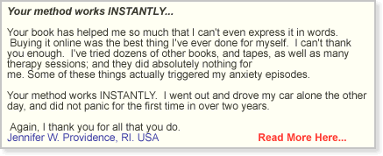
There is more...

-Learn to avoid making the one mistake almost everyone makes during a panic attack episode.
-You may have heard the reassuring fact that panic attacks are not life threatening but did you know exactly why this is? Being fully educated on the latest research (2005) will help you understand the true nature of panic attacks.
-What you eat and how you exercise today will effect the power and intensity of your next panic attack. In addition Panic Away outlines the foods, the correct exercises along with some massage pressure points that will completely eliminate all background anxiety.

Other courses and treatments out there are not showing you how to do this. Rather than fully empowering you, they teach coping mechanisms and strategies on how to get over a panic attack once it happens. That is not good enough. Just coping with this condition is not good enough. People need a program that teaches them how to free themselves from ever having a another panic attack again. That is the only kind of result you are interested in, right?
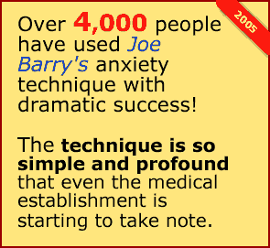
I Joe Barry, have been teaching this new revolutionary approach to dealing with anxiety and panic attacks for over five years now and the results are astounding people.
To give you a little background, I was in my second year of debilitating panic attacks when I discovered this powerful technique that stopped panic attacks in their tracks
I had been studying the cognitive behavior approach for dealing with panic attacks from some of the top psychologists when I developed this technique.The real breakthrough came when I made some startling observations about how a panic attack fuels and generates itself. I developed the technique on the principal that if you extinguish the fuel that powers the panic attack, you eliminate its reoccurrence.
I began teaching small groups of people my discovery with results that even surprised me. People were reporting instant panic elimination and further research confirmed that the technique I taught was not only instantly effective but also a permanent solution to all forms of panic and anxiety disorders.
I have since taught the One Move™ technique to thousands of people around the world and have received much acclaim for the work.
Have You Thought About How Anxiety Holds You Back?
Imagine if you will...
Planing holidays or travel without fear of anxiety.
Never fearing to leave your home or to be alone.
Having the belief to trust your body is not in any danger whatsoever.
Making appointments or socializing with people and never dreading you might have to leave unexpectedly half way through.
Going about your business daily without any lingering anxiety or anxious thoughts in your mind.
Giving a speech or presentation without any concern of having a panic attack.
Watching your close relationships improving as the barrier of fear is removed.
Feeling confident to fly ,drive or travel by any means you choose without concern.
Stopping nocturnal panic and anxiety that can keep you up at night.
Doing the one thing you love that panic attacks may be stopping you from doing, be it hill-walking to scuba diving.
Feeling really free again. -Not caught in feelings or thoughts of disconnected reality.
Being free from unsettling thoughts that can circle your mind.

Fact: A Panic Attack Will Not Harm You
I know when you are in the middle of a panic attack it feels like this terrifying experience is so intense, it might just kill you! You feel an array of unusual bodily sensation from dizziness, rapid heart beat to tingles right through your body. You fear you may have a heart attack or that the anxiety will push you over the edge mentally.
I want to reassure you that even thought the sensations can be terrifying, they will not cause you harm. There is very good medical studies to back this up. In fact panic attacks are not too dissimilar from a good aerobic exercise workout.
So What Can I Teach You?... What Makes My Technique So Special ?
Firstly, My technique is completely unique and proving daily to be an absolute success when it comes to treating anxiety and panic attacks. I have extensive experience working through my own anxiety and then that of countless others. While going through my own anxiety episode I studied the best psychologists working in the field. I learnt a huge amount from them but not enough to get me panic free. Then almost by accident I stumbled on a technique that brought it all together and got me immediately anxiety free . Over the years working with people I developed the technique, honed it down, and made it more understandable so that everyone could apply it. This is years of experience I want to share with you.
Secondly, I am a perfectionist. If you work with me I am dedicated to your well being. Having suffered from panic attacks I would never promote something unless it was getting truly remarkable results. I am not interested in half hearted results, I want you to cross the finish line just like I did and move beyond this anxiety issue that is holding you back. I truly believe you will get full recovery using my program. Please do not mistake this for Internet hype or an exaggerated sales pitch.
Thirdly, I love results. In the end this is all about the results.- Results Results Results.
I will use the exact same procedure I used to get results for all the people I have worked for. That is what drives me to get this information out there to the wider public who suffer from anxiety and panic attacks. I'll teach you the most critical information you need to know to overcome your anxiety today.

How Did I Get Someone With 30 years Of Panic Attacks Completely Anxiety Free?
...I used the exact same technique I am going to share with you. I will help you quickly break down any negative pattern that might be stopping you from getting better. I get countless letters, emails phone calls from people telling me how much of a difference this program has made to their lives.
Here is a recent example:
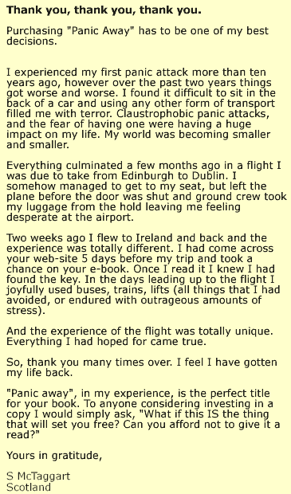

Please Don't Let Your Mind Fool You Into Thinking Your Anxiety Is Unique And Not Curable
That is simply not true and I have the experience to back that claim up. There are no lost causes -no matter how long you have been suffering from anxiety. You must not simply go on coping with this condition. You must embrace the opportunity to change all of that today. It is so very important to remove these self imposed limitations and be rid of that which is holding your life back.
You Must Make The Move Towards An Anxiety Free Life
-It Will Not Find You
Things start to happen instantly when you begin my program. An internal mental or cognitive shift happens whereby you no longer fear having a panic attack.That is a major breakthrough for everyone. Suddenly your general anxiety drops away and you are restored to your more confident self.
I Have Been Researching This For Over 10 Years
-Now You Can Benefit - Here Is How...
During my anxiety period I studied the research papers from the academics and I read every book I could get my hands on, you might be familiar with some of these popular authors on the subject of anxiety:
Edmund J. Bourne, - Robert Handly, - Pauline Neff, - Lucinda Bassett
There was however still something missing from all I read....
I tried all the exercises I did the relaxation and breathing techniques but nothing was shifting this deep fear of my next dreaded panic attack. It was very frustrating for quite some time. Then while experimenting with a few new ideas it dawned on me how to extinguish the very fuel the panic attack is driven by. This changed everything, I could now put myself in all the situations I feared without having to worry about having a panic attack.
Cutting the fuel of the panic attacks had some great knock on bonuses, the obsessive worries and unwanted thoughts disappeared as well. It was like a dense fog lifted. Once I had moved clear of this fog of anxiety it became clear what mistakes I was making and how a simple change in thinking was all that was needed to advance my recovery. I want to share this vital understanding with you right now in order for you to get the exact same powerful results.
What top medical professionals think about my technique
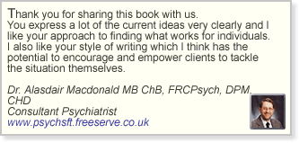
Allow me to be briefly boastful...
In a marketplace crowed with products and courses telling you they have the solution to your anxiety problem it is very hard to find something new that is truly unique and effective. Nothing I have come across is getting results like the Panic Away program. What I have found is that there is a lot of rewriting of old cognitive behavior therapies and mixtures of relaxation/visualization techniques to help ease the anxiety.
Don't get me wrong these can be very effective at reducing general anxiety levels but they do not go to the very heart of the matter. The people I work with have usually tried all those familiar techniques and are now looking for something more effective- Something that will really accelerate their recovery.Something that will stop them having to ever have another worry about anxiety again.
You see, I needed to develop a program that tackled the anxiety on two fronts:
1) The elimination of all Panic Attacks.
2) Reduce the persons general anxiety that causes the unwanted thoughts and everyday anxiety.
Taking this approach has led to countless success stories such as:
No More...
fear of leaving the house in case of a panic attack.
No more fear of getting stuck somewhere you can't excuse yourself from.
No more making excuses why you cannot make it to a social engagement.
No more putting off holiday plans or business travel.
No more fear of business meetings or situations where you are asked to speak.
No more fear of getting stuck in traffic.
No more living in a very trapped existence.

Do You Want To Experience All of This For Yourself Absolutely Risk Free?
I am making the program available to download to your computer right now. You will learn the exact technique I have been teaching people that is getting the kind of results that were thought not possible just a few short years ago.
Together We Will Get You Anxiety Free!
Let me skip to the best bit
Important October Update:
Many people write to tell me about the thousands of dollars they spent on doctors, therapists, and medication when in the end, all they really needed was the technique contained in 'Panic Away'. I have never believed in charging unnecessary high fees for this assistance and expertise so I think you will find this week's update particularly interesting.
Order now and take advantage of a unique discount for this week.I have set myself the goal of getting as many people as possible this life changing course, so at certain times I am slashing the online price. This is about people over profit. You have visited the site during a unique promotional period!
For Three Days Ending
October 17, 2005
I am slashing the price from $138 to $47
That's a huge saving of over 70%
Due to the fact that the course is now being distributed in electronic format, to download to your computer instantly, I have been able to cut my overheads and offer it during a limited period for this greatly reduced price.
But that's not all...
Not only are you getting the full program when you order today (at a knock down price) but I will also be giving you my private email address which only my private clients have access to. You will get one-to-one feedback should you request it. Have troublesome question answered or simply write to tell me how well you are getting on. I'd love to hear from you.
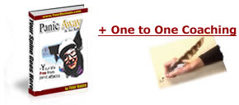
The renowned 'Panic Away' course and one-to-one coaching sessions with top anxiety expert, all for just
$47
(£26 sterling in UK)

-It really doesn't get better than that.
Save yourself time, money, and future frustration. Be done with anxiety now, and cross the finish line here.
Act now Order Here You can appreciate that this offer needs to be limited. The offer will then need to return to its regular price of $138
This is an incredible 70% off !
What I really hope for, by offering this at a minimal rate, is that you will let others know of the great results you achieve and help spread the word faster to any friends or colleagues that may suffer from a similar anxiety issue.

"Thank you, I just read this book and already I feel more confident. I've read and bought other panic solutions and this one finally taught me how to accept the anxiety and panic in a way I could understand. I wish I'd known about this when I was a teen-ager. Anyway I feel better just knowing about this technique. Thank you again for caring about people.
P.S. I can't believe this valuable information costs so little, I bought one program for almost $300.00!"
R. J.
Woodbridge, Suffolk.
Hi. I was expecting the usual suspects to appear in the book such as 'breathing techniques' and 'positive affirmations', that approach has never really worked for me personally. I was surprised to discover how short, blindingly simple and quick your technique is. OK here goes -I am actually looking forward to my next panic attack!
BJ Lyons
_____________________________________________
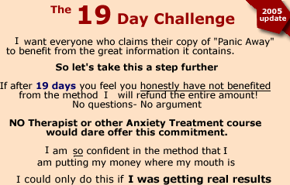

If you are taking advantage of the special offer you can begin using the Panic Away program within the next 5 minutes!
The Online course can be very easily downloaded in one simple step. This means that you can get started straight away and begin eliminating panic and anxiety attacks this very moment.
No exaggeration. Just an honest proposal:
What If By The End Of Today, You Were Not Going To Ever Fear Another Panic Attack.
Please do not make the mistake of dismissing this opportunity out of fear that it may be hype or some Internet con. If you have reservations let me put your mind at rest. I or my staff are more than happy to talk to you if you need reassurance, contact us here.
You really deserve to invest in yourself today especially with this rock bottom price and allow yourself the opportunity to be truly anxiety free. With the Panic Away program you will live panic free.
Order Here

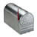

I look forward to getting a letter or email from you as soon as possible, telling me about your experience using the program for overcoming panic attacks and acute anxiety. Even though I get an enormous amount of e-mail, please don't forget to write. I'd love to hear your story!

Thank you for your time.
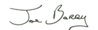

P.S. Remember, you must order while the offer is showing to avail of the special price and free consultations. Please don't miss this opportunity. Why pay extra for this powerful information when you can get it at a reduced rate right now?
P. P.S. I guarantee that if you do not benefit from the technique you can return it for a prompt 100% refund. Trust me on this, that is a guarantee I firmly stand by! If you do not feel the course has improved your condition I do not want you money- true to my word.
P.P.P.S The fastest way to order is directly online with the SECURE SERVER. The payment process is regulated and controlled by a third party ensuring your complete security at all times. Keep in mind that when you use the order form on the Secure Server, you can download the entire program within 5 minutes.

(Some of the above testimonies have kindly agreed to be contacted by e-mail should you wish to confirm their testimonials)
Still Not Sure If Panic Away Is Right For You ?
Read Glenda's story...

Site Design BBM Design. All material is copyright protected 2005©
All material provided on the web site is provided for informational or educational purposes only.
No content is intended to be a substitute for professional medical advice, diagnosis or treatment. Consult your physician regarding the applicability of any opinions or recommendations with respect to your symptoms or medical condition.

