Wuthering Heights
Emily Bronte

Heathcliff The main character. Orphaned as a child, he is constantly on the outside, constantly losing people. Although he and Catherine Earnshaw profess that they complete each other, her decision to marry Edgar Linton almost destroys their relationship. He spends most of his life contemplating and acting out revenge. He is abusive, brutal, and cruel.
Catherine Earnshaw The love of Heathcliff’s life. Wild, impetuous, and arrogant as a child, she grows up getting everything she wants. When two men fall in love with her, she torments both of them. Ultimately, Catherine’s selfishness ends up hurting everyone she loves, including herself.
Edgar Linton Catherine’s husband and Heathcliff’s rival. Well-mannered and well-to-do, he falls in love with and marries Catherine. His love for her enables him to overlook their incompatible natures.
Cathy Linton Daughter of Catherine and Edgar. A mild form of her mother, she serves as a reminder of her mother’s strengths and weaknesses. (Note: For the purpose of clarity, the younger Catherine is referred to as “Cathy” in this Note, and her mother is referred to as “Catherine.” This convention is not used in the original text.)
Linton Heathcliff Son of Heathcliff and Isabella. Weak and whiny (both physically and emotionally), he serves as a pawn in Heathcliff’s game of revenge. He marries Cathy.
Hareton Earnshaw Catherine’s nephew, son of Hindley. Although uneducated and unrefined, Hareton has a staunch sense of pride. He is attracted to Cathy but put off by her attitude. His generous heart enables the two of them to eventually fall in love and marry. Hareton is the only person to mourn Heathcliff’s death.
Ellen (Nelly) Dean The primary narrator and Catherine’s servant. Although she is one person capable of relating the majority of the events that occurred, she is not without bias.
Lockwood Heathcliff’s tenant at Thrushcross Grange and the impetus for Nelly’s narration. Although he serves primarily as the catalyst for the story, Lockwood’s role is an outsider who happens to gain inside information. His visit to Wuthering Heights and subsequent actions directly affect the plot.
Mr. Earnshaw Catherine’s father. He brings Heathcliff into his family and soon favors the orphan over his own son, Hindley.
Mrs. Earnshaw Catherine’s mother. Not much is known about her, except that she favors her own son to Heathcliff, whom she does not like.
Hindley Earnshaw Catherine’s brother. Jealous of Heathcliff, he takes a bit of revenge on Heathcliff after his father dies. He proves to be no match for Heathcliff, however, eventually losing his son and his family’s home.
Frances Earnshaw Hindley’s wife. A sickly woman who dies soon after Hareton is born.
Joseph Servant at Wuthering Heights. A hypocritical zealot who possesses a religious fanaticism that most find wearisome.
Mr. and Mrs. Linton Edgar’s parents. They welcome Catherine into her home, introducing her to the life in upper society. They die soon after nursing Catherine back to health.
Isabella Edgar’s sister. Her infatuation with Heathcliff causes her to destroy her relationship with her brother. She experiences Heathcliff’s brutality first hand. She flees to London where she gives birth to Heathcliff’s son, but her attempts to keep her son from his father fail.
Zillah Heathcliff’s housekeeper. She saves Lockwood from a pack of dogs and serves as Nelly’s source of information at Wuthering Heights.
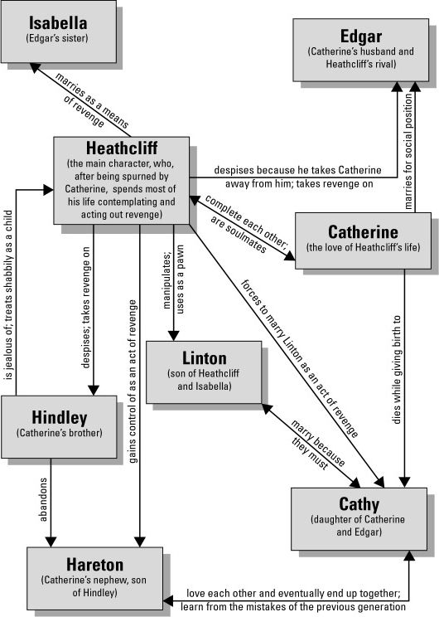

Jane Eyre
Charlotte Bronte
Jane Eyre The orphaned protagonist of the story. When the novel begins, she is an isolated, powerless ten-year-old living with an aunt and cousins who dislike her. As the novel progresses, she grows in strength. She distinguishes herself at Lowood School because of her hard work and strong intellectual abilities. As a governess at Thornfield, she learns of the pleasures and pains of love through her relationship with Edward Rochester. After being deceived by him, she goes to Marsh End, where she regains her spiritual focus and discovers her own strength when she rejects St. John River’s marriage proposal. By novel’s end she has become a powerful, independent woman, blissfully married to the man she loves, Rochester.
Edward Fairfax Rochester Jane’s lover; a dark, passionate, brooding man. A traditional romantic hero, Rochester has lived a troubled wife. Married to an insane Creole woman, Bertha Mason, Rochester sought solace for several years in the arms of mistresses. Finally, he seeks to purify his life and wants Jane Eyre, the innocent governess he has hired to teach his foster daughter, Adèle Varens, to become his wife. The wedding falls through when she learns of the existence of his wife. As penance for his transgressions, he is punished by the loss of an eye and a hand when Bertha sets fire to Thornfield. He finally gains happiness at the novel’s end when he is reunited with Jane.
Sarah Reed Jane’s unpleasant aunt, who raises her until she is ten years old. Despite Jane’s attempts at reconciliation before her aunt’s death, her aunt refuses to relent. She dies unloved by her children and unrepentant of her mistreatment of Jane.
John Reed Jane’s nasty and spoiled cousin, responsible for Jane’s banishment to the red-room. Addicted to drinking and gambling, John supposedly commits suicide at the age of twenty-three when his mother is no longer willing or able to pay his debts.
Eliza Reed Another one of Jane’s spoiled cousins, Eliza is insanely jealous of the beauty of her sister, Georgiana. She nastily breaks up Georgiana’s elopement with Lord Edwin Vere, and then becomes a devout Christian. But her brand of Christianity is devoid of all compassion or humanity; she shows no sympathy for her dying mother and vows to break off all contact with Georgiana after their mother’s death. Usefulness is her mantra. She enters a convent in Lisle, France, eventually becoming the Mother Superior and leaving her money to the church.
Georgiana Reed Eliza’s and John’s sister, Georgiana is the beauty of the family. She’s also shallow and self-centered, interested primarily in her own pleasure. She accuses her sister, Eliza, of sabotaging her plans to marry Lord Edwin Vere. Like Eliza, she shows no emotion following their mother’s death. Eventually, Georgiana marries a wealthy, but worn-out society man.
Bessie Lee The maid at Gateshead who sometimes consoles Jane by telling her entertaining stories and singing her songs. Bessie visits Jane at Lowood, impressed by Jane’s intellectual attainments and ladylike behavior. Bessie marries the coachman, Robert Leaven, and has three children.
Mr. Lloyd The kind apothecary who suggests that Jane be sent to school following her horrifying experience in the red-room. His letter to Miss Temple clears Jane of the accusations Mrs. Reed has made against her.
Mr. Brocklehurst The stingy, mean-hearted manager of Lowood. He hypocritically feeds the girls at the school starvation-level rations, while his wife and daughters live luxuriously. The minister of Brocklebridge Church, he represents a negative brand of Christianity, one that lacks all compassion or kindness.
Helen Burns Jane’s spiritual and intellectual friend at Lowood. Although she is unfairly punished by Miss Scatcherd at Lowood, Helen maintains her poise, partially through her loving friendship with Miss Temple. From Helen, Jane learns tolerance and peace, but Jane can’t accept Helen’s rejection of the material world. Helen’s impressive intellectual attainments inspire Jane to work hard at school. Dying in Jane’s arms, Helen looks forward to peace in heaven and eventual reunion with Jane.

Maria Temple The warm-hearted superintendent at Lowood who generously offers the girls bread and cheese when their breakfasts are inedible. An impressive scholar, a model of ladylike behavior and a compassionate person, Miss Temple is a positive role model for Jane. She cares for Jane and Helen, offering them seedcake in her room and providing Helen with a warm, private bed when she is dying.
Miss Miller Teacher for the youngest students at Lowood who greets Jane on her first night at the school.
Miss Scatcherd The history and grammar teacher at Lowood. She constantly humiliates and punishes Helen Burns.
Miss Smith A red-cheeked teacher at Lowood who is in charge of sewing instruction.
Madame Pierrot The likeable French teacher at Lowood who comes from Lisle, France.
Miss Gryce Jane’s roommate and fellow teacher at Lowood.
Mrs. Alice Fairfax The housekeeper at Thornfield; Jane first thinks she is Thornfield’s owner. She warmly welcomes Jane to Thornfield, providing a contrast to Jane’s cold treatment at Gateshead, the Reed’s house. Mrs. Fairfax doesn’t approve of Jane and Rochester’s marriage because of the differences in their ages and social classes. When she leaves Thornfield after Jane’s mysterious disappearance, Rochester offers her a generous pension.
Blanche Ingram The beautiful and haughty society woman Rochester pretends to love. Her comments about the insipidness of governesses show the lack of respect that most governesses faced in the wealthy Victorian families where they worked. As a fortune-hunter, more interested in Rochester’s money than his personality, Blanche is depicted as an unappealingly materialist model of femininity.
Adèle Varens Jane’s pupil at Thornfield, whose foreignness, like her mother’s, reveals many of Jane’s Anglocentric prejudices. Adèle initially shows unpleasantly French (in Jane’s opinion) characteristics such as sensuality, materialism, and egocentrism. But a firm British education erases all of these negative characteristics, and by the end of the novel Adèle has become a docile, pleasant companion for Jane.
Céline Varens Once Rochester’s mistress, this Parisian opera singer used Rochester for his money, although she actually despised him. Rochester discovers her true feelings when he overhears a conversation between her and one of her other lovers. He immediately breaks off relations with her. She eventually runs away to Italy with a musician, abandoning her daughter, Adèle, whom she claims is Rochester’s child. Her hypocrisy, sensuality, and materialism make her another negative mode of femininity.
Bertha Antoinetta Mason Rochester Rochester’s wife, the crazy woman in the attic. A Creole woman from Spanish Town, Jamaica, Bertha was betrothed to Rochester by the arrangement of their fathers, who planned to consolidate their wealth. This beautiful and majestic woman disintegrates into debauchery, coarseness, and, eventually, madness soon after their wedding. Bertha’s mother was also mad and the novel suggests that Bertha’s problems are a maternal inheritance. Following the deaths of his brother and father, Rochester returns to England with Bertha, locking her up in the third story of Thornfield, with Grace Poole as her keeper. She occasionally escapes her imprisonment, perpetrating violence whenever she gets loose. Eventually, she sets fire to Thornfield. Bertha is another example of unsavory foreignness in the novel.
Richard (Dick) Mason Bertha’s brother, a weak-willed man. During his visit to Thornfield, he is bitten and stabbed by Bertha when he goes up to her room alone. When he learns of Jane’s upcoming wedding to Rochester, he arrives to thwart Rochester’s bigamous intentions.
Grace Poole Bertha’s keeper at Thornfield who has a predilection for gin. Her alcohol-induced lapses allow Bertha to escape from the third floor and perpetrate various crimes in the house, including the eventual fire that destroys Thornfield and maims Rochester. Grace is initially accused of perpetrating all of Bertha’s sins in the household.
Mother Bunches Rochester’s alias when he’s disguised as a gypsy fortuneteller during a house party at Thornfield.
Hannah The Rivers’ elderly housekeeper who initially denies Jane access to Moor House. Jane chastises Hannah for her class prejudices, but she and Jane later become friends.
St. John (pronounced sin’jin) Rivers Jane’s cousin, St. John is a cold, despotic, excessively zealous. Unhappy with his humble position as the minister at Morton, St. John wants to become a missionary in order to meet his ambitions for power and glory. St. John tries to force Jane to marry him and move to India. Jane resists him, and he spends the rest of his life furthering British colonialism by forcing Christian values on the natives.
Diana and Mary Rivers St. John’s sisters and Jane’s cousins, Diana and Mary are exemplars of accomplished, benevolent, and intellectual women. Working as governesses, they show the ways intelligent, well-bred women are degraded by their positions in wealthy families. Diana’s support of Jane following St. John’s marriage proposal helps Jane maintain her independence when faced with his despotism.
Rosamond Oliver The beautiful and flirtatious daughter of a wealthy man in Morton, Rosamond finances the girls’ school in Morton. Although she seems to love St. John, she has become engaged to the wealthy Mr. Granby before St. John leaves for India. While St. John is physically attracted to her, he realizes that Rosamond would never be a good wife for him, because of her light-hearted, almost shallow, personality.
Mr. Oliver Rosamond’s father and the only wealthy man in Morton. While the Rivers are an ancient and esteemed family, the Olivers have “new money.” He approves of St. John’s talents, finding him a suitable husband for his daughter, but thinks missionary work is a waste of St. John’s intellect.
Mr. Briggs John Eyre’s attorney, Briggs prevents Jane’s bigamous marriage to Rochester and searches for her following her uncle’s death so she can claim her inheritance.
John Eyre Jane’s and the Rivers’ uncle, John Eyre makes a fortune as a wine merchant in Madeira. Although he plans to adopt Jane, he dies before they ever meet, but leaves his entire fortune—20,000 pounds—to her. He quarreled with Mr. Rivers, and therefore, didn’t leave his money to the Rivers children.
Alice Wood Hired by Rosamond Oliver, Alice is an orphan who serves as Jane’s assistant at Morton.
The elderly servants who care for Rochester at Ferndean after Thornfield is destroyed by the fire.

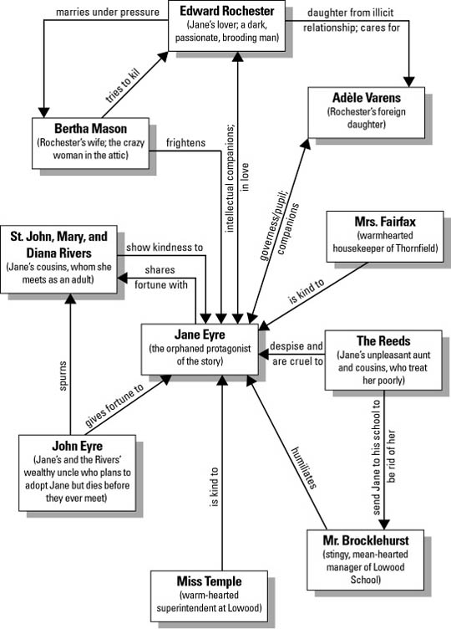

Pride and Prejudice
Jane Austen
Elizabeth Bennet An intelligent and spirited young woman who possesses a keen wit and enjoys studying people’s characters. Although she initially dislikes Darcy, circumstances cause her to reassess her negative impression of him, and she eventually falls in love with him.
Fitzwilliam Darcy A wealthy, proud man who falls in love with Elizabeth and reveals a generous, thoughtful nature beneath his somewhat stiff demeanor.
Mr. Bennet Elizabeth’s ironic and often apathetic father. Unhappily married, he has failed to provide a secure financial future for his wife and daughters.
Mrs. Bennett Elizabeth’s foolish and unrestrained mother who is obsessed with finding husbands for her daughters.
Jane Bennett A gentle and kind-hearted young woman who is Elizabeth’s confidant and the oldest of the Bennet daughters. She falls in love with Bingley but is cautious about revealing the depth of her feelings for him.
Mary Bennett The pretentious third Bennet daughter, who prefers reading over socializing.
Catherine (Kitty) Bennett The Bennet’s peevish fourth daughter, who joins her sister Lydia in flirting with soldiers.
Lydia Bennett The Bennet’s immature and irresponsible youngest daughter. Mrs. Bennet’s favorite, she shocks the family by running away with Wickham.
Charles Bingley A good-natured and wealthy man who falls in love with Jane. He is easily influenced by others, especially by his close friend Darcy.
Caroline Bingley Bingley’s shallow and haughty sister, who befriends Jane and later snubs her. She attempts to attract Darcy’s attentions and is jealous when Darcy is instead drawn to Elizabeth.
Mr. and Mrs. Hurst Bingley’s snobbish sister and brother-in-law. Mrs. Hurst spends most of her time gossiping with Caroline, while Mr. Hurst does little more than play cards and sleep.
George Wickham A handsome and personable fortune hunter to whom Elizabeth is initially attracted. He eventually runs off with and is forced to marry Lydia.
Lady Catherine De Bourgh Darcy’s arrogant aunt, who dominates Mr. Collins and entertains hopes that her daughter will marry Darcy.
Miss De Bourgh Lady Catherine’s sickly, bland daughter.
Colonel Fitzwilliam Darcy’s well-mannered and pleasant cousin, who is interested in Elizabeth, but who needs to marry someone with money.
Georgiana Darcy Darcy’s shy but warmhearted sister.
Mr. Collins Mr. Bennet’s ridiculous cousin, who will inherit Longbourn after Mr. Bennet’s death. Upon Lady Catherine De Bourgh’s recommendation, he seeks a bride, first proposing to Elizabeth and then to Charlotte Lucas.
Charlotte Lucas Elizabeth’s sensible and intelligent friend, who disappoints Elizabeth by marrying Mr. Collins for money and security.
Sir William and Lady Lucas Charlotte’s parents and the Bennets’ neighbors.
Mr. and Mrs. Gardiner Mrs. Bennet’s intelligent and cultivated brother and sister-in-law.
Mr. and Mrs. Phillips A country attorney and his vulgar wife, who is Mrs. Bennet’s sister.

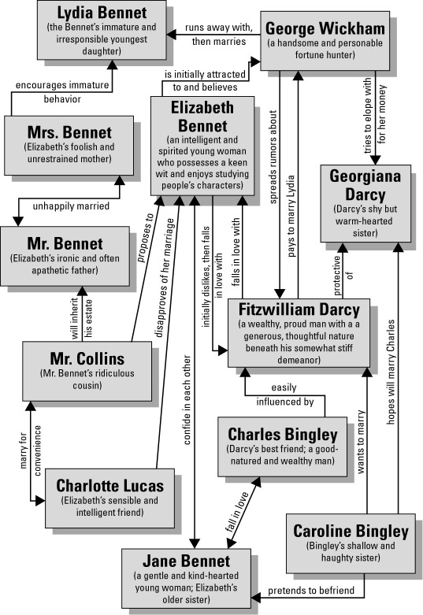

Frankenstein
Mary Shelley
Victor Frankenstein Creator of the monster. Victor becomes obsessed with the idea of creating the human form and acts upon it. Immediately after creating the monster, he falls into a depression and fear. He leaves the school and returns home to his family, only to find tragedy there. Not fully aware of the consequences of his creating a new human, he spends his entire life trying to destroy the same creation.
The monster The creature created by Victor Frankenstein while at the University of Ingolstadt. “Formed into a hideous and gigantic creature,” the monster faces rejection and fear from his creator and society. The monster’s rejection from society pushes him to commit murder against his creator’s family.
Henry Clerval Victor's best friend who helps Victor in his time of need. The monster kills Henry after Victor breaks his promise of creating a female companion for the monster. He studies language at the University of Ingolstadt and is totally unaware of Victor’s creation.
Elizabeth Lavenza The orphan child taken in by the Frankenstein family and lovingly raised with Victor. Elizabeth later becomes Victor's wife and is killed by the monster on their honeymoon. She is a champion for the poor and underpriviledged.
Alphonse Frankenstein Victor's father. He suffers from illness probably brought on from his advanced age and depression from the events that have happened.
Caroline Beaufort Frankenstein Victor's mother. Caroline dies of scarlet fever when Victor is 17. Caroline was very involved in charity work—much like Mary Shelley and her mother Mary Godwin—especially for families in poverty.
William Frankenstein Victor's youngest brother who is killed by the monster. Symbolically, William’s murder is the turning point of the novel, when turmoil engulfs the Frankenstein family and all innocence is lost in the family. Also, William’s death signals for the reader the end of Victor’s belief that his actions can have no consequences.
Justine Moritz The housekeeper for the Frankenstein family. Accused of William's murder, Justine is the stolid martyr who goes to her death with grace and dignity. If William’s death symbolizes the loss of innocence, Justine’s death marks the end of all that is noble and righteous.
The De Lacey family M. De Lacey, Felix, Agatha, and Safie. The monster’s adopted family. Exiled from France for treason against their government.
Robert Walton Arctic explorer on his way to find a Northwest Passage through the Arctic Ocean from Russia to the Pacific Ocean. Robert finds Victor Frankenstein near death, listens to his tale, and records it in letters to his sister Margaret Saville.
Margaret Saville Robert's sister. Robert writes to her detailing the events that transpire on the voyage and Victor's story.

